**Grand Jobs Developer Documentation – Adding a new file to the project**

To add a new file to the project, when the project is open in sublime text, right click the folder in which you wish to add a new file, and click new file.

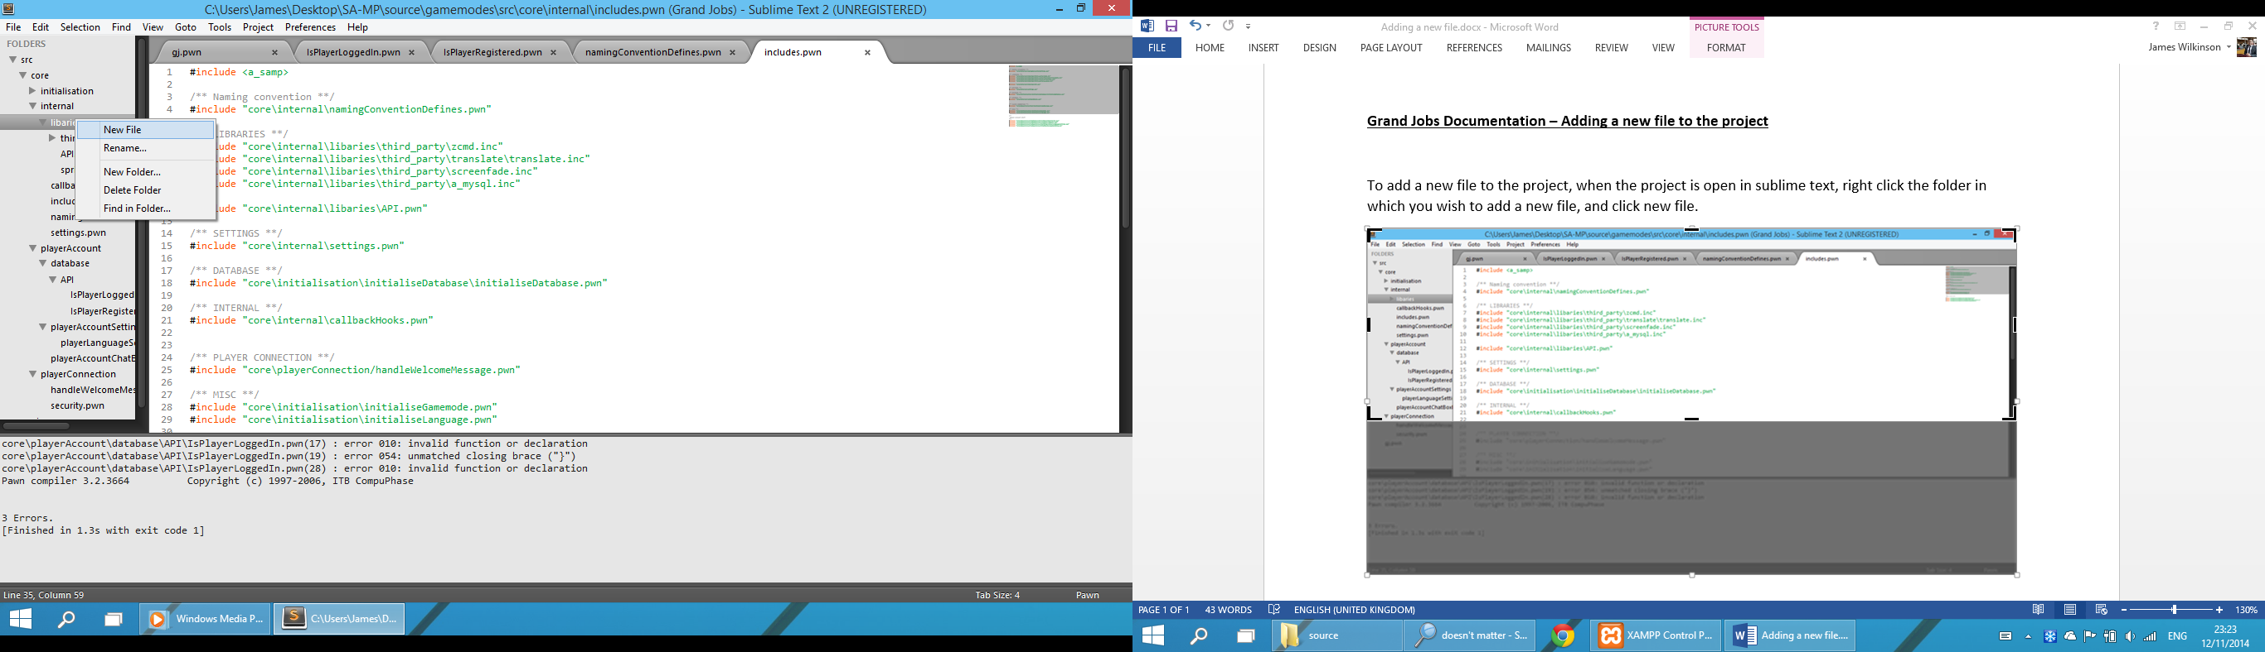

Now you’ll see your new file open in a new text tab called untitled. Inside the new tab press CTRL + S to save it and give it a relevant name.

**Including the file in the project source code to be compiled**

Next, you need to include the file in the project source code for it to compile.

Inside the main src folder, go to the internal folder, you’ll see a folder called includes.pwn.

Add a new line with the path to your file inside this folder in the following syntax:

#include "path\to\file \filename.pwn” – note it doesn’t have to be a .pwn file it can be .inc etc.

Now, when you compile the project the new file will be included.